MINI-ONE
REFERENCE
Version 1 – September 2026
Edward Sicoe
github.com/esicoe/mini-one

1 CHANGELOG
Version | Date (yyyy/mm/dd) | Change Note
0 | 2026/09/16 | Release
1 | 2026/09/28 | Removed via shorting GND and D−

2 SUBSYSTEM DIAGRAM
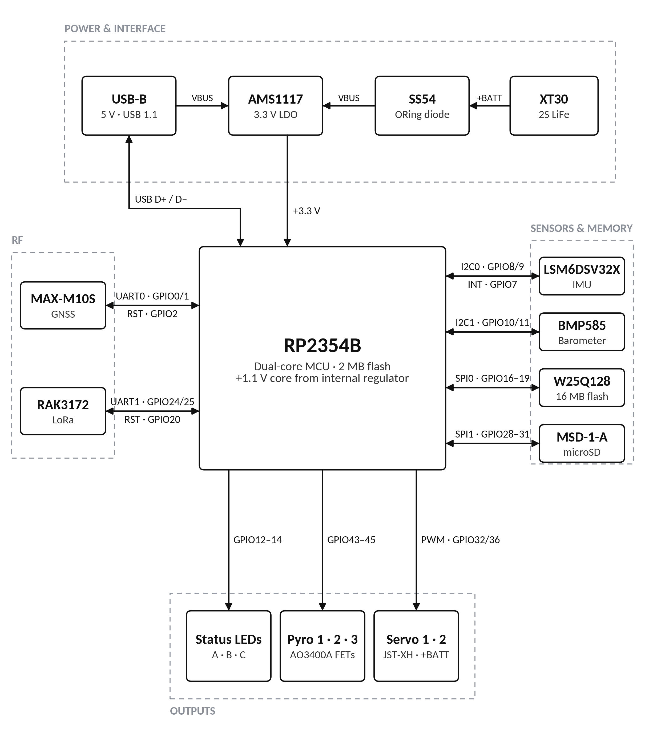
3 PCB DIAGRAM
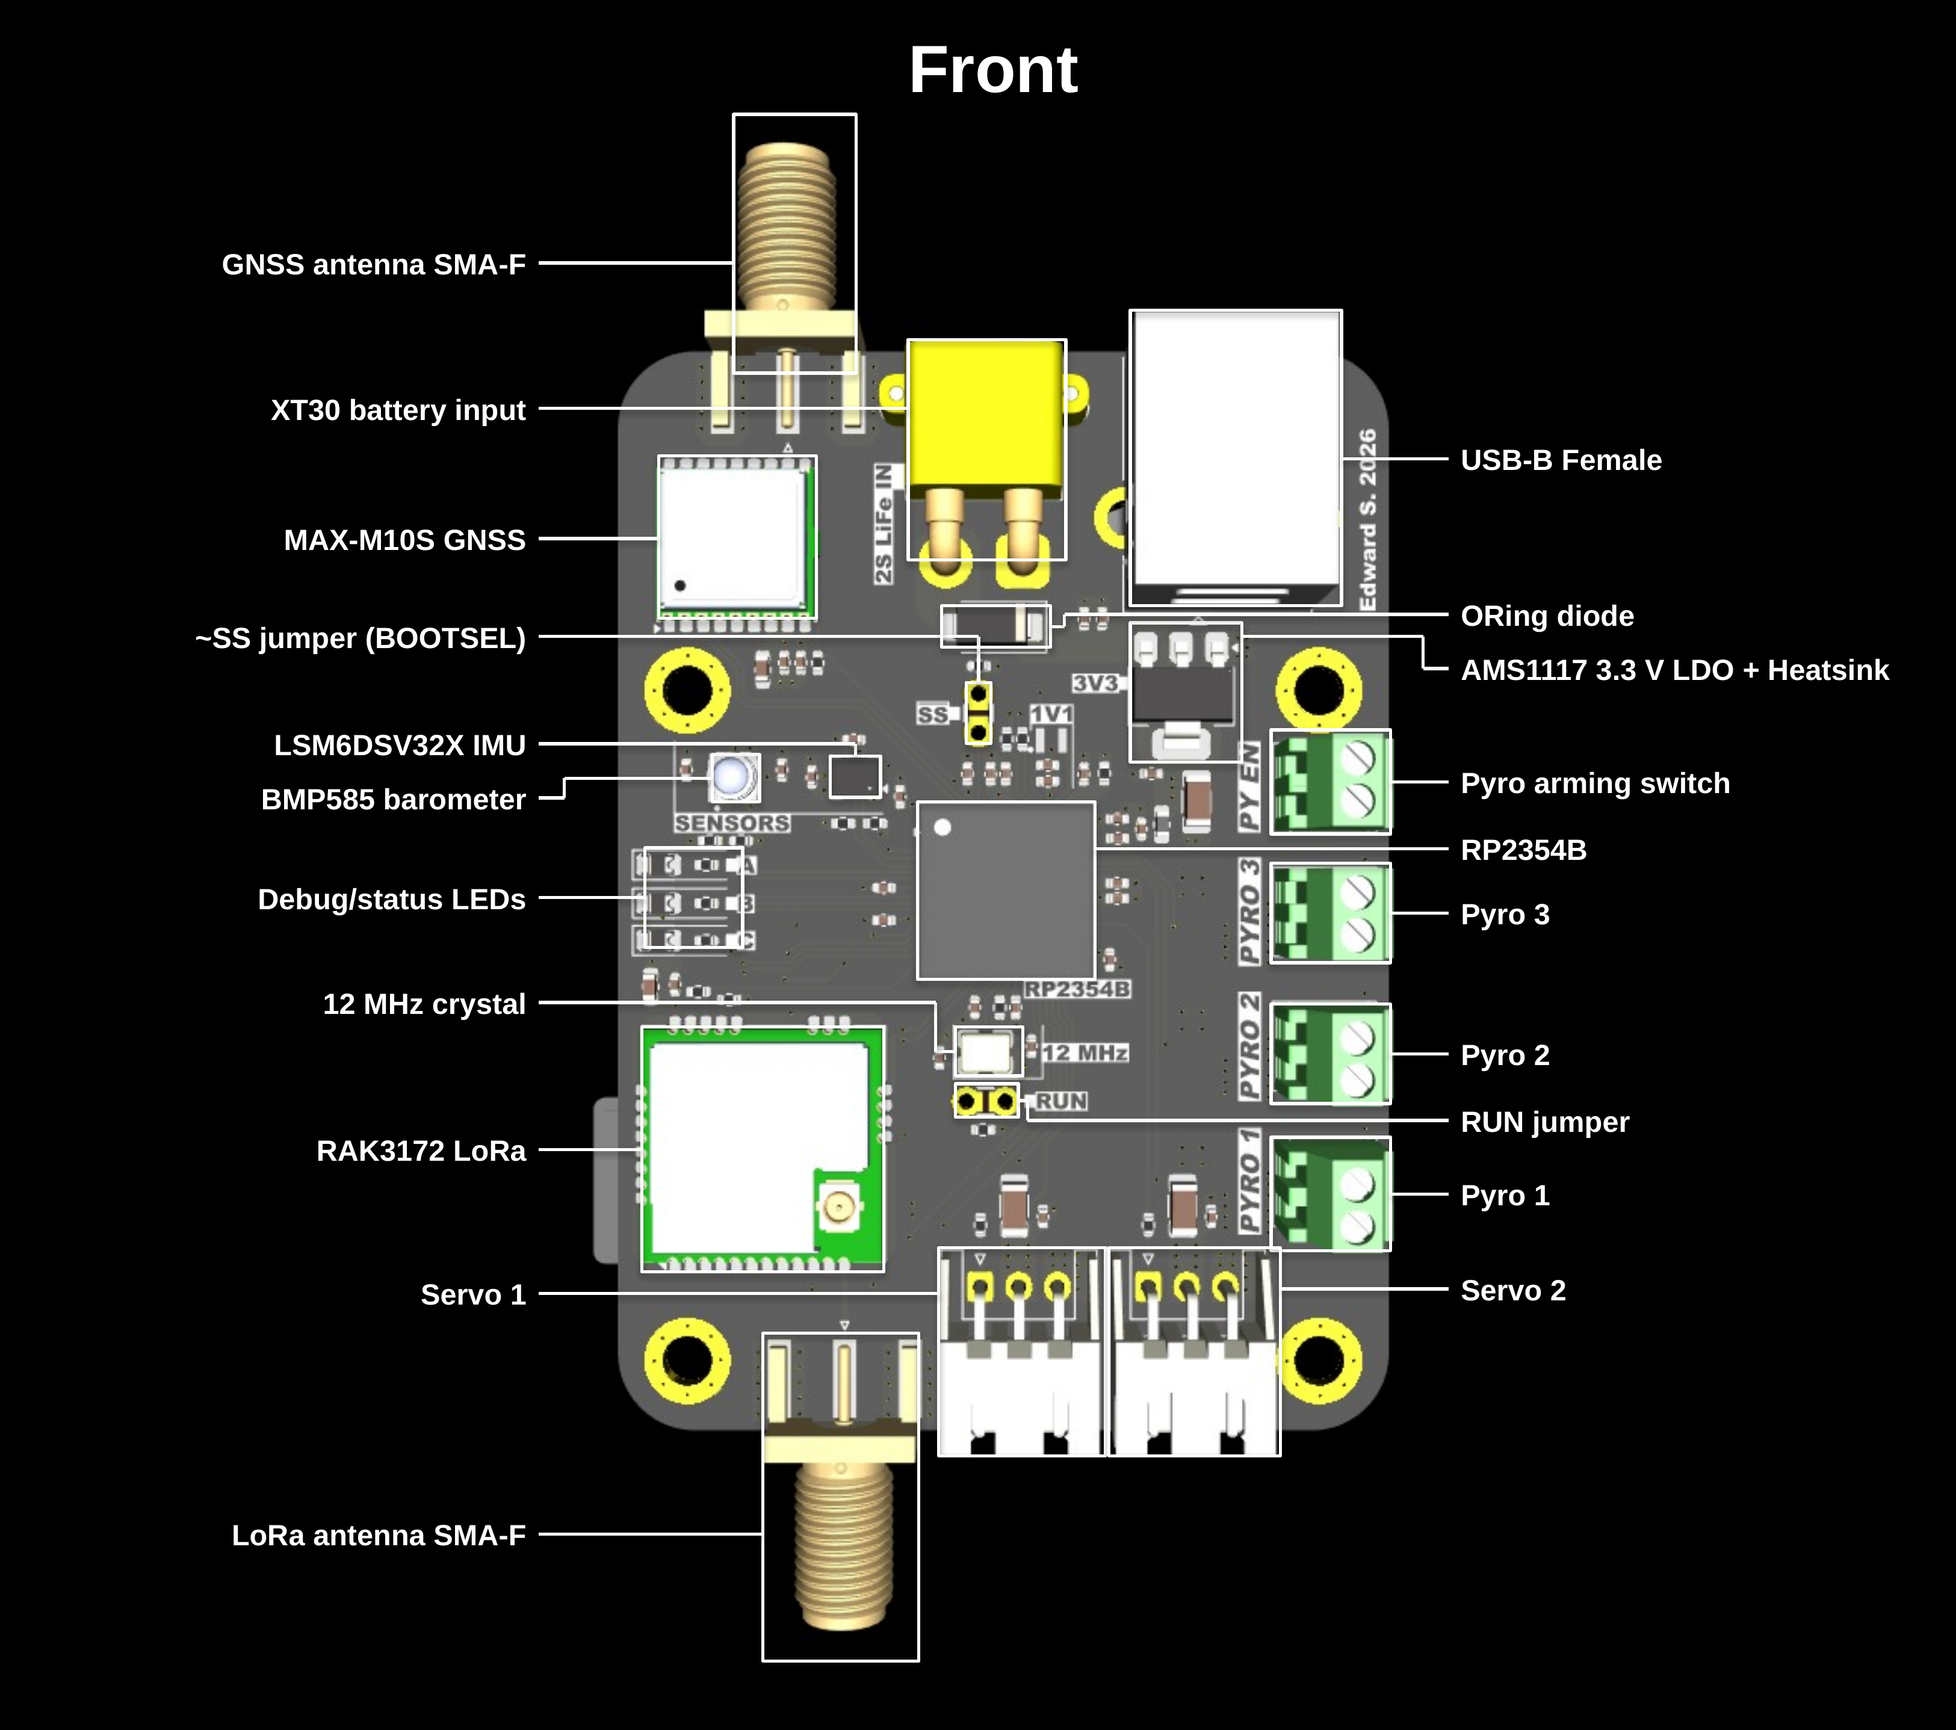
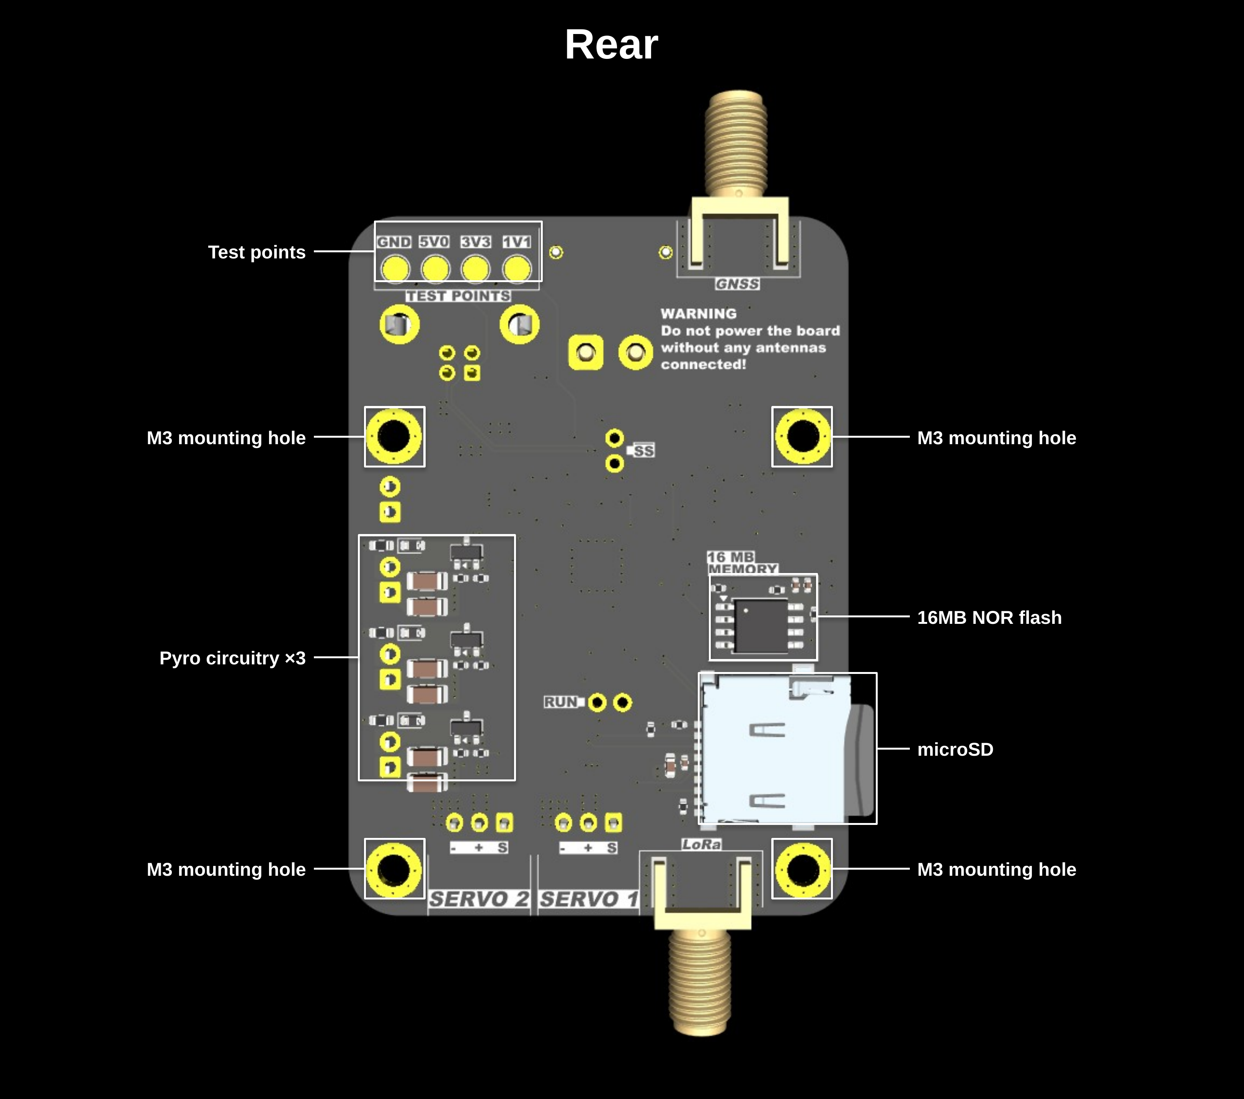
4 TABLE OF COMPONENTS
Component | MPN | Datasheet | Details
Microcontroller | RP2354B | Datasheet | Dual Cortex-M33 / Hazard3 cores at 150 MHz, 520 KB SRAM, 2 MB in-package flash, 48 GPIO (QFN-80).
IMU | LSM6DSV32X | Datasheet | 6-axis IMU: ±32 g accelerometer, ±4000 dps gyroscope. I²C address 0x6A, INT1 on GPIO7.
Barometer | BMP585 | Datasheet | Pressure and temperature sensor with gel-filled port. I²C address 0x46. INT tied to GND, keep interrupts disabled.
Flash memory | W25Q128JVSIQ | Datasheet | 128 Mbit (16 MB) SPI NOR flash, SOIC-8. Onboard flight log.
microSD socket | MSD-1-A | Datasheet | Push-push microSD socket, used in SPI mode.
GNSS | MAX-M10S-00B | Datasheet | u-blox M10 GNSS module, passive antenna. UART at 9600 baud by default. Set dynamic model to Airborne <4 g.
LoRa radio | RAK3172-8-SM-NI | Datasheet | STM32WLE5-based LoRa module, 863–928 MHz, up to 22 dBm. AT commands over UART at 115200 baud.
3.3 V regulator | AMS1117-3.3 | Datasheet | 1 A LDO (SOT-223) fed from VBUS.
ORing diode | SS54 | Datasheet | 40 V, 5 A Schottky. ORs the battery onto VBUS.
Pyro FET | AO3400A | Datasheet | 30 V N-channel MOSFET (SOT-23). Low-side switch for each pyro channel (×3).
Crystal | ABM8-272-T3 | Datasheet | 12 MHz, 10 pF load. System and USB clock.
Core regulator inductor | AOTA-B201610S3R3-101-T | Datasheet | 3.3 µH (0806) for the RP2354B internal 1.1 V regulator.
USB connector | USB1030-GF-P-B-B | Datasheet | USB-B receptacle, through-hole. 5 V input and USB 1.1.
Battery connector | XT30PW-M | Product page | XT30 male, horizontal PCB mount. 2S LiFe input.
Pyro / arm terminals | 282834-2 | Product page | 2-position, 2.54 mm terminal block (×4).
Servo connectors | S3B-XH-A | Datasheet | 3-pin JST-XH, side entry (×2). Powered from +BATT.
Antenna connectors | 132289 | Product page | SMA edge-mount jack (×2) for GNSS and LoRa.
Status LEDs | KT-0805Y | Product page | 0805 yellow LED (×3).

5 COMPONENT PROGRAMMING REFERENCES
Component | Bus | Pico SDK reference
IMU | I²C0 | hardware_i2c
Barometer | I²C1 | hardware_i2c
Flash memory | SPI0 | hardware_spi
microSD | SPI1 | hardware_spi
GNSS | UART0 | hardware_uart
LoRa radio | UART1 | hardware_uart
Status LEDs | GPIO | hardware_gpio
Pyro channels | GPIO | hardware_gpio
Servos | PWM | hardware_pwm
USB | USB | pico_stdio_usb

